This is an official request from several concerned residents of N. Early Street to the City of Alexandria for a traffic study in order to obtain corrective measures regarding cut-through traffic on N. Early Street (between Braddock Road and Menokin Drive).

N. Early Street was designed to be a residential (local) street per the Alexandria Master Plan (Small Area Plans & Citywide Chapters)-- The 1974 Major Thoroughfare Plan classified streets into five categories: expressways, arterials, primary collectors, residential collectors and local streets.

N. Early Street was classified as the "lowest" category regarding traffic volume and type, a local street (accommodating local traffic) and was not designed nor classified to have the current cut-through and commercial traffic; this traffic is creating major safety/health issues for the residents on N. Early Street (NES).

There are three main issues that need to be addressed (see page 2 for further explanation of the issues):

1. Volume of Traffic (too many vehicles for the street design/width)
2. Speed of Traffic (speeding vehicles)
3. Types of Vehicles (many commercial cut-through vehicles, including box trucks, flat-bed trucks, dump trucks, tractor-trailers, taxi-cabs, buses, vans)

Major Safety/Health/Property Issues

- School buses and residents often encounter head-on traffic, and have to take evasive measures to avoid collision.
- Many speeders have plowed into parked cars/trees, driven up on lawns, and even overturned.
- Children living on the street are at risk while playing in their own front yards (or walking/biking on the sidewalk) due to the dangerous traffic situation. People walking down the sidewalks (from surrounding neighborhoods, many with babies in strollers or dogs on leashes, as well as NES residents) face the same danger.
- Residents (children and adults) have difficulty sleeping during "quiet hours" due to the traffic noise.
- Utility lines have been pulled down by large trucks.
- Vibration from heavy vehicles has damaged houses on NES, including causing the collapse of several ceilings.
- N. Early Street is frequently used as an overflow parking lot for local schools; this turns NES into a one-lane hazardous road.

Background:

1. The volume of traffic has increased dramatically since the BRAC Center opened. Also, people are using NES as a cut-through to avoid the intersection at Quaker Lane/Braddock Road/King Street and the North Van Dorn/Braddock Road intersection. NES traffic volume is increasing with population and commercial growth, word-of-mouth and possibly GPS routing. With the upcoming completion of the Super-Safeway, new stores (such as Fresh Market) in Bradlee Shopping Center, more development of the BRAC/Mark Center area, and the future redevelopment of the Beauregard corridor, traffic volume will continue to increase (along with incidents).

2. Drivers speed on N. Early Street. Cars have on several occasions lost control due to speeding. This is a critical safety issue.

3. NES is used as a cut-through by many commercial vehicles, including large box trucks, delivery trucks and vans, mail trucks (UPS/Fed-Ex/USPS), dump trucks, flat-bed trucks, tractor trailers, large commercial tour buses, and taxi-cabs. Some of these vehicles pertain to local construction (in violation of haul-permits), but many are just commercial vehicles cutting down NES to avoid the primary roads they should be using.

Immediate Action Request: We would like No Thru Truck signs as soon as possible (to stop construction vehicles and other large trucks now); then, we would like consideration of further corrective measures to be determined by the outcome of the study and resident consensus.

SUMMARY: N. Early Street is being used as a cut-through street when there are viable collector and arterial streets that can and should be used, since N. Early Street is a residential street, designated (and designed) as a local street. N. Early Street is also getting local construction traffic which has added to the problem. We believe N. Early Street will receive more and more traffic as the surrounding areas continue to grow and develop. This is an issue that needs to be addressed now, with eyes on the future.

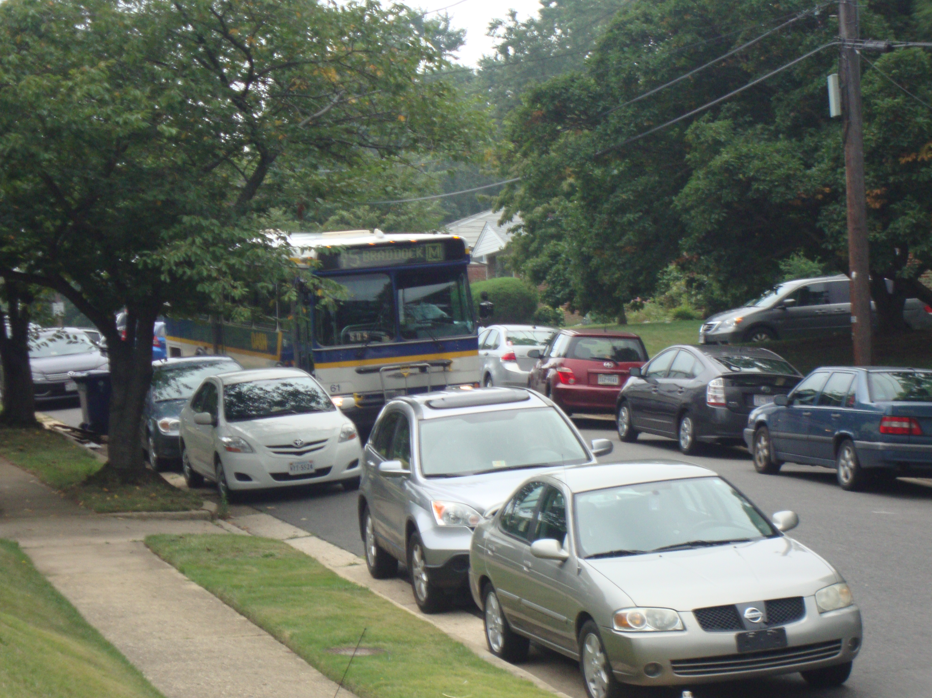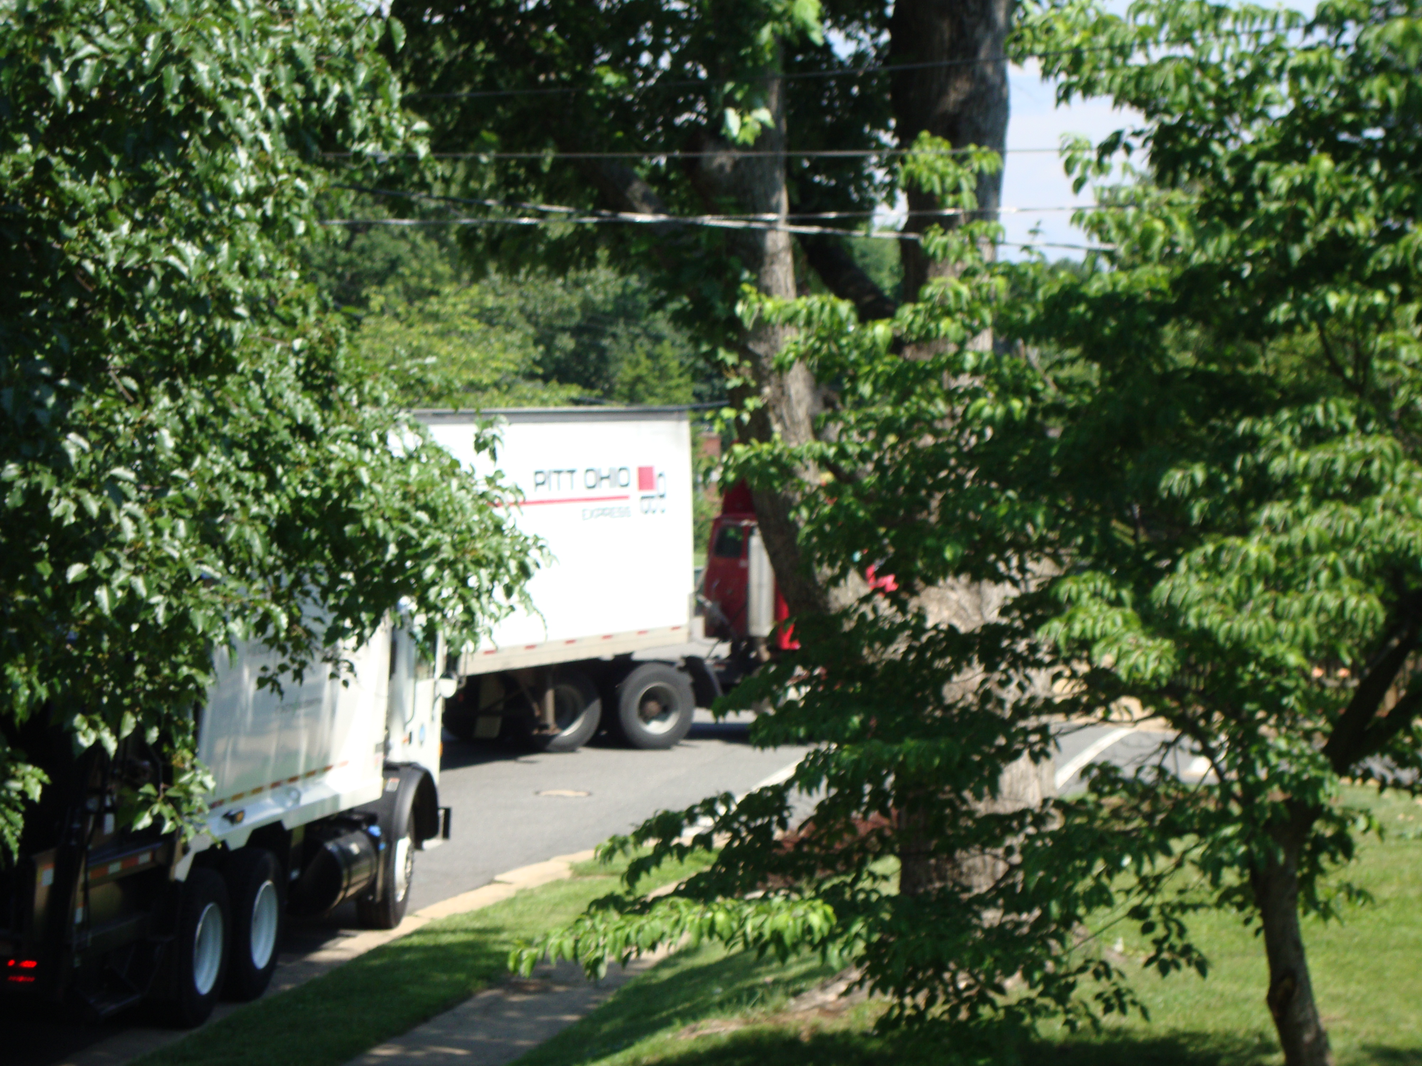
N. Early Street is frequently used as an overflow parking lot Two commercial trucks using NES as a cut-through.
for area events, as shown here.

Signed by James and Carolyn Wallace (2241); Kate Hungerford (2233); Anna Dunn (daughter) on behalf of Guillermo and Victoria Fuentes (long-time residents--2248)

