Cool the HOT Lanes—AGAIN?



https://www.washingtonpost.com/news/dr-gridlock/wp/2015/11/20/virginia-to-extend-i-95395-hot-lanes-north-to-d-c-line/

The State of Virginia is again proposing building HOT Lanes inside the Beltway in I-395. The proposal first came in 2009 and was opposed by Alexandria and Arlington which defeated it in court in 2010 on environmental/air pollution grounds. This new proposal no longer has an exit/access in Shirlington and does not go past the Pentagon. It also calls on restricting exit/access at Seminary Road to HOV vehicles only (nfi). The plan will add another lane in the HOV section by using the shoulders and narrowing the width of the lanes so that wider vehicles and busses would only be able to travel in the middle lane. No new lanes will be provided across the Potomac River or in DC.

Per Nan’s assessment, there is no indication that the existing HOT Lanes will ever be profitable, except to the Texas Company that constructed them. The Australian Company Trasurban, which owns and operates the lanes and toll system, has had losses so far; $46 M in 2013 and $23 million in 2014. The total cost of the I-95 lanes was $900 M of which Virginia taxpayers paid $100 M, and for the Beltway 495-lanes $1.9 B of which VA paid $400 M. Transurban is guaranteed a profit for the number of vehicles using the HOT Lanes and, if too many HOV vehicles travel for free, then the State of Virginia makes up the cost of those vehicles to the company. Data on how much VA pays to Transurban for these commuters is unknown by Nan.

According to the Washington Post, Virginia’s Secretary of Transportation held a conference call on 20 November 2015 with Regional leaders in which they were told that “Virginia really needs these HOT lanes.” Mayor Euille and Councilman Paul Smedberg both voiced Alexandria’s concerns, as did Arlington County’s Jay Fisette.

The Virginia government and a private partner have reached agreement on another expansion of the HOT lanes network in the DC region. This program will replace the High-Occupancy Vehicle system on Interstate 395 up to the area near the Pentagon, which will take the 95 Express Lanes north eight miles to the DC line.

State Transportation Secretary Aubrey Layne said in an interview that VDOT and the Transurban company are in accord on a plan to add an extra lane to today’s two-lane HOV system while making relatively minor adjustments in the rest of the I-395 set up. Layne informed the local governments of Arlington and Fairfax counties and the City of Alexandria and said he was looking forward to working with them on advancing the program to construction in 2017, with an opening two years later.

As was the case with the 95 Express Lanes, which opened in December, drivers who meet the HOV-3 rules will be able to travel for free in the I-395 express lanes, as long as they have an E-ZPass Flex transponder switched to the HOV setting. Drivers who don’t meet the three-person carpool standard will have access to these new high-occupancy toll lanes if they are willing to pay a variable toll that rises as high as it takes to maintain free-flowing traffic. Those drivers would pay the toll via E-ZPass.

“This proposal is not the same as proposals in the past,” Layne said. The Virginia Department of Transportation had originally planned for the 95 Express Lanes to extend up to the Potomac River but cut the project off just north of the Capital Beltway after Arlington County filed a lawsuit. The new plan, Layne said, will guarantee funding for new or enhanced transit service and carpooling along the I-95/395 corridor. It scratches an old plan that would have built a new ramp at the Shirlington interchange on I-395.

The HOV ramp now under construction at Seminary Road, near the Mark Center, still will be for HOV traffic only, even under the HOT lanes plan. The drivers who enter the HOT lanes there will have to meet the HOV rules, so toll payers will be excluded. (Nan’s query: how are they going to do that?)

Next steps

In his letter to the jurisdictions, Layne said: “The Commonwealth and its private partners are committed to a robust public engagement effort. As the project is further developed there will be public meetings in all affected jurisdictions, individual meetings with local homeowner associations and businesses, and ongoing updates and opportunities to provide input.”

The State also must begin an environmental assessment on the impact of converting the HOV lanes to HOT lanes. Layne said the State also will begin a study to identify transit, carpool, vanpool and other strategies to improve travel along the corridor. He said these studies would be coordinated with the affected jurisdictions.

Jennifer Aument, Transurban’s general manager for North America, said in a statement: “Our 95 Express Lanes customers are experiencing significant time savings on I-95 and have communicated strong support for extending the lanes to DC. We are pleased to have an opportunity to work in partnership with VDOT to meet that demand. “We have worked to refine the design of the project to reduce impacts on surrounding roadways and communities, and are committed to working alongside VDOT to keep residents, commuters and other stakeholders engaged and informed as we move the project forward. By funding improvements through a public-private partnership, we are able to preserve scarce public transportation dollars to be used on other regional priorities and provide a revenue stream for transit that will continue to fund new options for travelers in the I-95 corridor for many years to come.”

While the plan adds a lane in the middle of the interstate, it does not significantly affect the footprint of the highway. Some extra space may be needed for sound walls, Layne said, but the plan does not call for the State to take any private properties. (Nan’s comment: sound walls hanging from poles?)

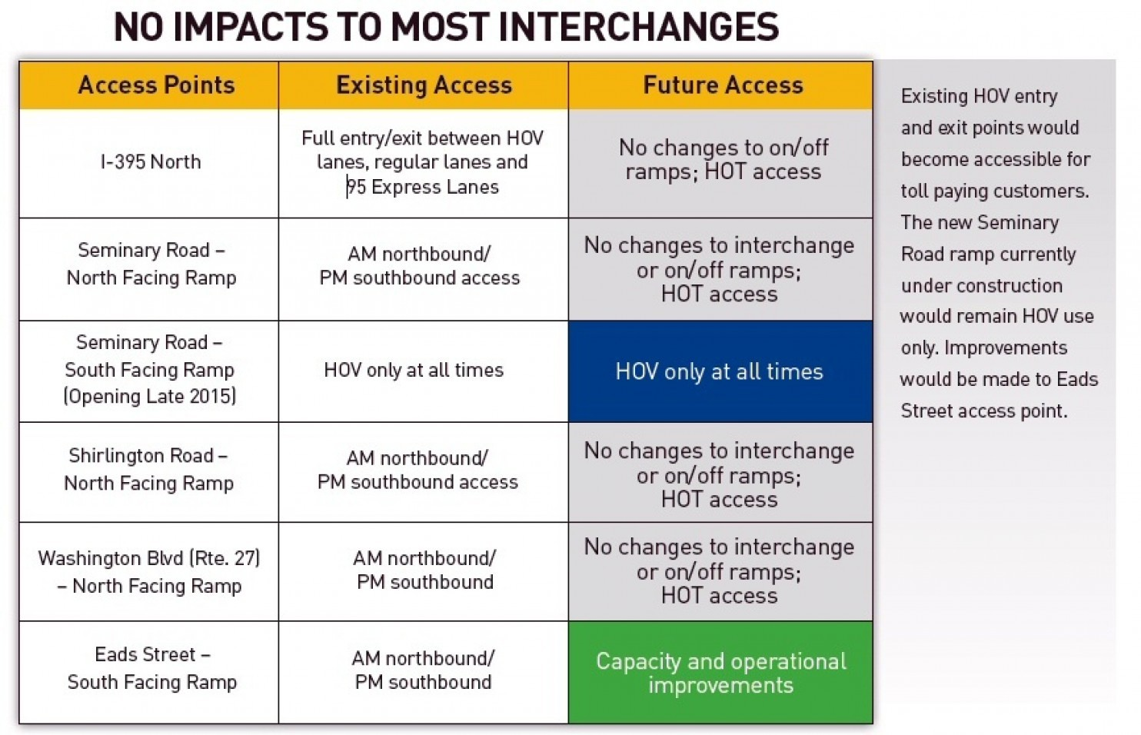
Chart shows anticipated impact of the 395 Express Lanes on today’s I-395 HOV system.

(Nan’s comment: these lanes are at gridlock at least one day a week, if not more, adding another lane of traffic to them will not make them work more efficiently. Access for emergency vehicles will be problematic given the lack of shoulders.)

